|  |  |
| --- | --- |
| **Project Number:** | **202** |
| **Project Title:** | Ammonia in Water, using the HACH Kit Method |
| **Method Code:** | NITAxx |
| **Method Title:** | Ammonia Nitrogen - Water |
| **CC number:** | *(Introduction of new method NMXXX)* |
| **Report prepared by:** | Lee Kennedy |

TABLE OF CONTENTS

1. Objective 3

2. Background 3

3. Scope 3

4. EXPERIMENTAL DESIGN 3

5. DATA ANALYSIS 4

5.1. Linearity 4

5.2. Sensitivity 4

5.3. Selectivity 4

5.4. Matrix Effects 4

5.5. Precision 4

5.6. Bias 4

5.7. Ruggedness 4

5.8. Measurement Uncertainty 5

6. Discussion 5

7. Conclusion 5

8. References 5

# Objective

To validate testing the ammonia nitrogen levels in water using the HACH test kit.

# Background

Ammonia nitrogen has been done by NITA01 in the past. The method used is:

The ammonia in the sample is separated from other nitrogen fractions by distillation from a buffered solution. The ammonia in the distillate is absorbed in a solution of boric acid and then determined by titration with sulphuric acid.

The proposed HACH method is simpler and does not require the distillation step.

Most samples have a quite low ammonia level but there are a scattering of high results.

Of 122 samples submitted since January, 61 were negative and the majority of the remainder were less than 5 mg/L. The negative results were due to the sample having a smaller titration compared to the blank.

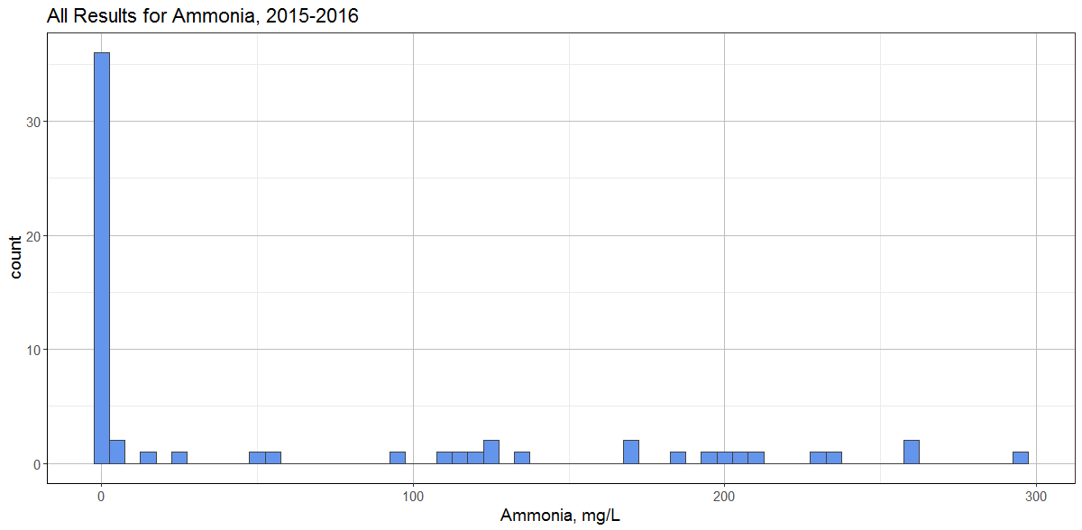

# Scope

Effluents.

# EXPERIMENTAL DESIGN

The kit has high and low level calibrations. Both will be validated. The high range is to 50mg/L. This is lower than that achievable by NITA01, where there is no upper limit as it is a distillation and titration.

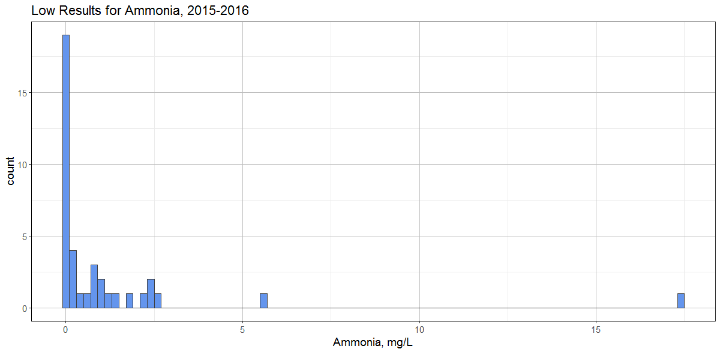

# DATA ANALYSIS

# Linearity

xxx.

# Sensitivity

Txxx.

# Selectivity

xxx.

# Matrix Effects

xxx.

# Precision

xxx.

# Bias

xxx.

# Ruggedness

xxx.

# Measurement Uncertainty

xxx

# Discussion

xxxx.

# Conclusion

xxxx.

# References

xxx